H.T No
Regulations:
A17

Sreenidhi Institute of Science and Technology
(An Autonomous Institution)
Code No: 6AC41 Date: 08-Mar-2021 (AN)

B.Tech II-Year II- Semester External Examination, March/April - 2021 (Supplementary)
Elements of Electrical Engineering (CSE and IT)

Time: 3 Hours Max.Marks:75

Note: a) No additional answer sheets will be provided.
b) All sub-parts of a question must be answered at one place only, otherwise it will not be valued.
c) Missing data can be assumed suitably.

ANSWER ANY 5 OUT OF 8 QUESTIONS. EACH QUESTION CARRIES 15 MARKS.

Bloom's Cognitive Levels of Learning (BCLL)

Remember | L1 | Apply | L3 | Evaluate | L5
Understand | L2 | Analyze | L4 | Create | L6

 |  |  | BCLL | CO(s) | Marks
1. | a) | Using Thevenin’s theorem calculate the current I through the resistance connected between the terminal A & B (All resistances are in ohms). As shown in below figure.  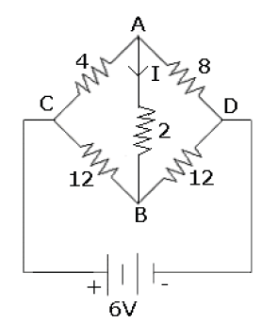 | L3 | CO1 | [8M]
 | b) | Distinguish between ideal and practical voltage source? | L2 | CO1 | [7M]
2. | a) | A coil having a resistance of 10Ω and an inductance of 0.2H is connected in series with a 100μF capacitor across a 230V, 50Hz supply,  Calculate  i) The active and reactive components of the current.  ii) The voltage across the coil, Draw the phasor diagram. | L3 | CO2 | [8M]
 | b) | State and explain Faradays laws of Electromagnetic induction. | L1 | CO2 | [7M]
3. | a) | Derive the expression of induced EMF of DC generator. | L2 | CO3 | [8M]
 | b) | An 8 pole lap wound DC generator has 960 conductors, a flux of 40mWb per pole. and is driven at 400 rpm. Find induced EMF. | L4 | CO3 | [7M]
4. | a) | With neat diagram discuss the principle of working of a transformer. | L2 | CO4 | [8M]
 | b) | A 200/400V, 50Hz 1 phase transformer on test gave following readings:  O.C (L.V): 200V, 0.7A, 70W,  S.C (H.V): 15V, 10A, 80W. Find voltage regulation at 0.8 p.f lagging at full load. | L4 | CO4 | [7M]
5. | a) | How is a rotating magnetic field produced in a three phase induction motor? Explain in detail with relevant phasors. | L2 | CO5 | [8M]
 | b) | Give in detail the operating principle of a three phase induction motor. | L1 | CO5 | [7M]
6. | a) | Explain the following features of the indicating instruments. | L2 | CO6 | [8M]
 | b) | With a neat sketch, explain the principle of operation of the repulsion type and attraction type moving iron instruments. | L2 | CO6 | [7M]
7. | a) | Write down KVL and KCL in point form. | L1 | CO1 | [5M]
 | b) | Find the average and RMS values of the saw tooth wave form shown in below Figure.  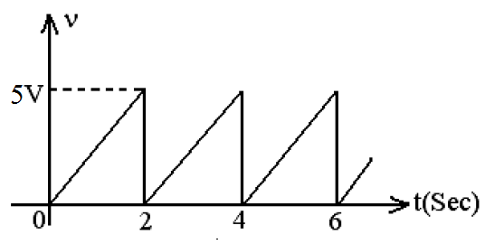 | L3 | CO2 | [5M]
 | c) | Derive condition for maximum efficiency of D.C. Generator. | L3 | CO3 | [5M]
8. | a) | Explain the constructional details of single phase transformer. | L2 | CO4 | [5M]
 | b) | Derive expression for torque developed in three phase induction motor. | L3 | CO5 | [5M]
 | c) | Explain essential requirements of indicating instruments with necessary diagrams? | L1 | CO6 | [5M]

-- 00 -- 00 –

